**Firewall Exploration**

Chawin Metah

Department of Computer Science, Purdue University Fort Wayne

ACS 54500: Cryptography and Network Security

Lab 5

Dr. Zesheng Chen

February 23, 2022

**Task 1: Implementing a Simple Firewall**

Similar to the previous labs, we download and unzip Labsetup.zip, which contains docker-compose.yml and other directories (Figure 1). Then, we use the command below to initiate network, as shown in Figure 2. This lab, we have four users: user1 (10.9.0.5) and other 3 users connected to router 10.9.0.11/192.168.60.11 (the diagram is shown in Firewall.pdf, available at https://seedsecuritylabs.org/Labs_20.04/Files/Firewall/Firewall.pdf).

unzip Labsetup.zip

dcbuild

dcup

**Figure 1**

*Labsetup.zip*

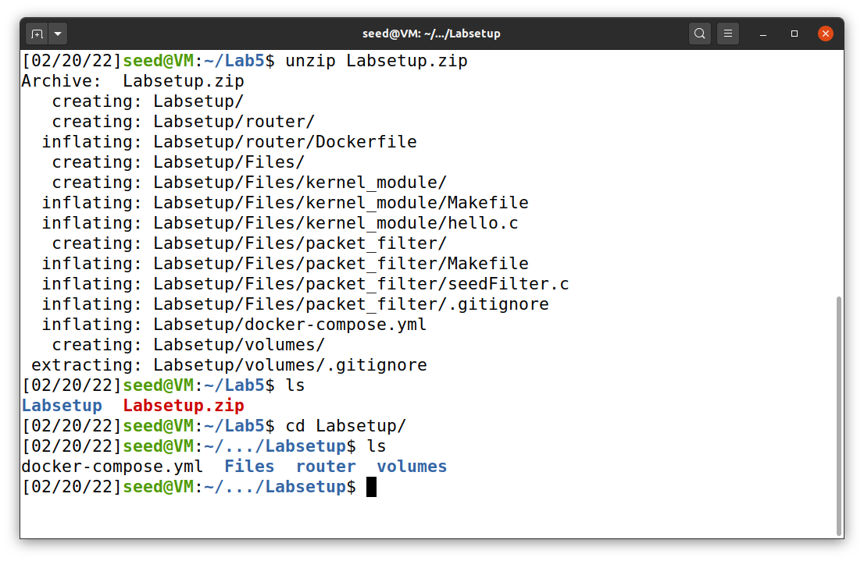

**Figure 2**

*Network initiation*

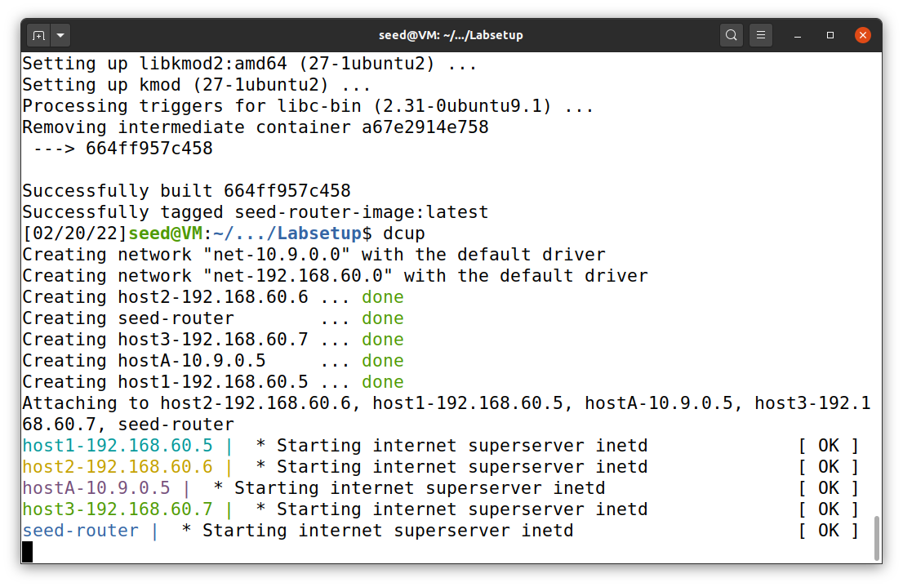

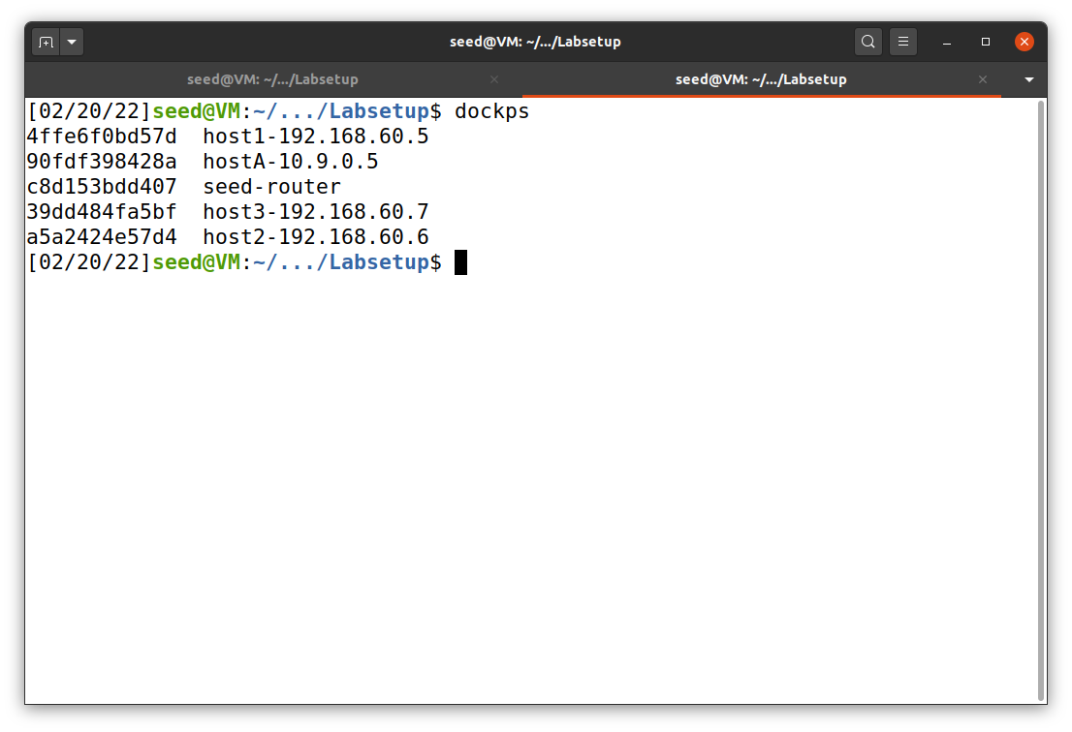

***Task 1.A: Implement a Simple Kernel Module***

The program hello.c is provided in the directory Files/kernel_module/, as shown in Figure 3. To begin, we need to create Makefile with the easiest command ever (Du, n.d.), as shown in Figure 3. The following command was used to create Makefile. After that, the terminal will show the output as shown in Figure 4.

make

**Figure 3**

*hello.c*

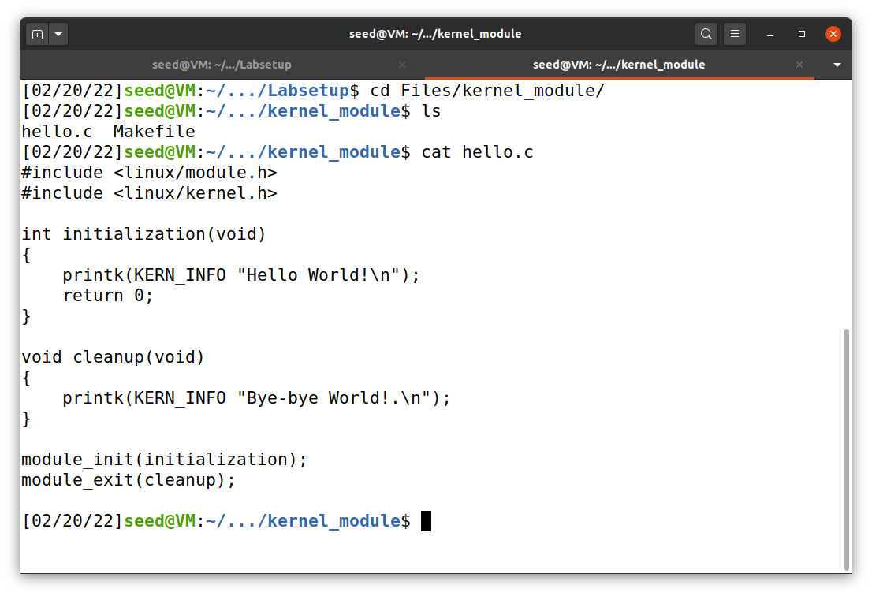

**Figure 4**

*Makefile creation*

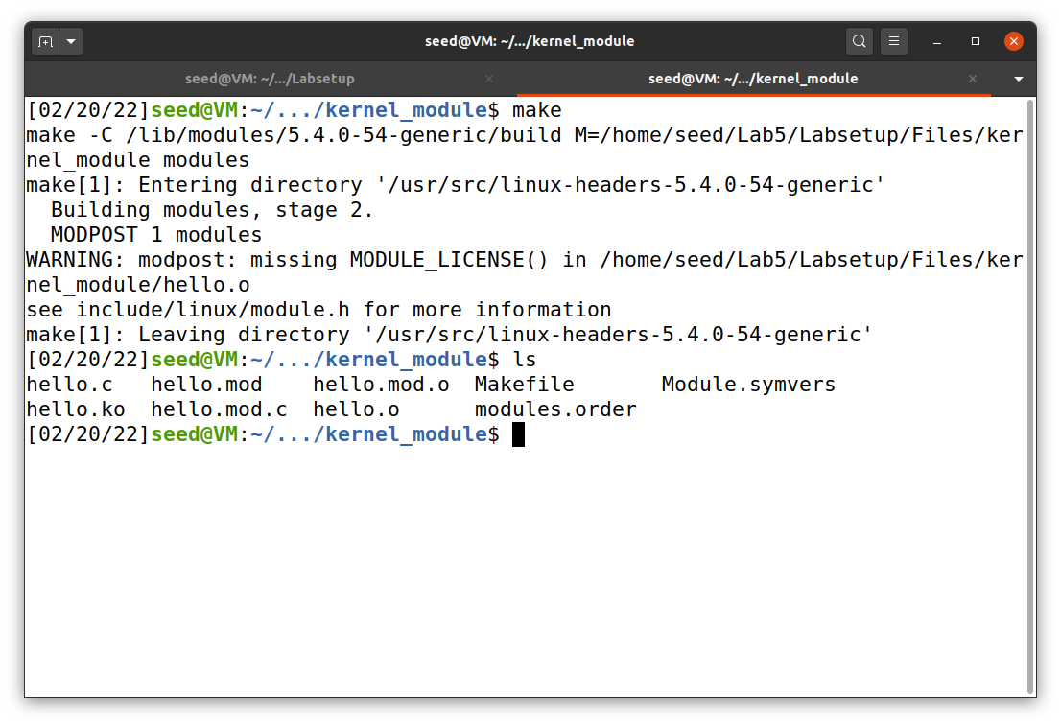

The command make automatically compile hello.c for us. The only thing that we have to do is to insert module and check the message with the commands below. Also, we can list an inserted module and remove the module. When we install or remove the module, the message will show up, as shown in Figure 6.

* sudo insmod hello.ko (inserting a module)
* lsmod | grep hello (list modules)
* sudo rmmod hello (remove the module)
* dmesg (check the messages)

**Figure 5**

*Installation of hello.ko*

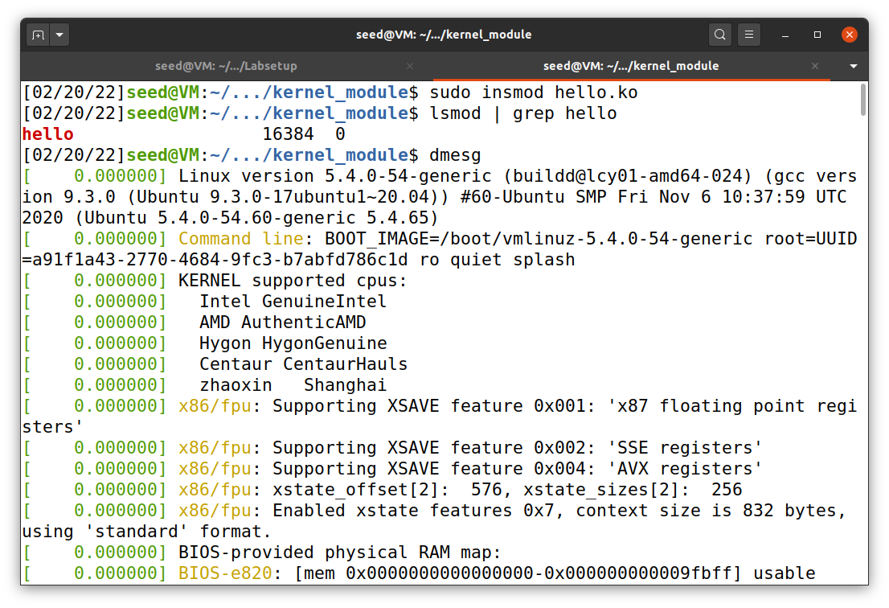

Show the message

List the module

Insert the module

**Figure 6**

*Message checking*

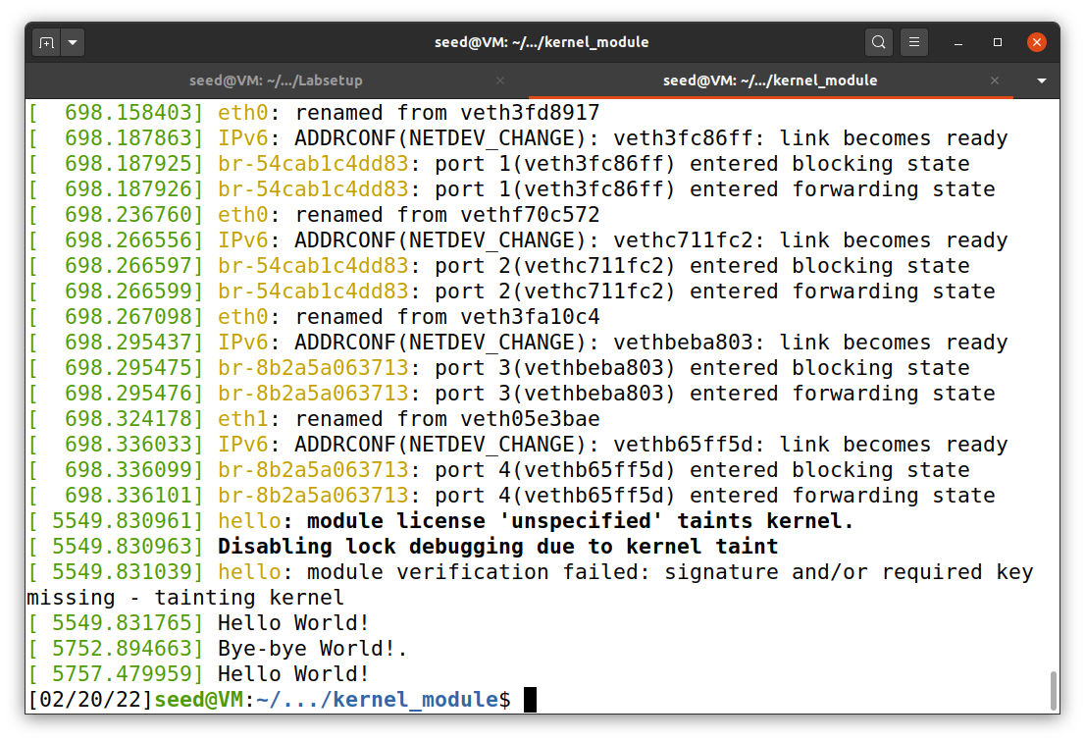

Module inserted

Module removed

Module inserted

***Task 1.B: Implement a Simple Firewall Using Netfilter***

For the first subtask, I made an adjustment to the seedFilter.c. The char ip[16] is now equal to "8.8.4.4" (in blockUDP function). The code is saved into my repository on GitHub. After I saved the file, I used make command and then insert the module with the command below (Figure 7).

sudo insmod seedFilter.ko

**Figure 7**

*Inserting seedFilter.ko*

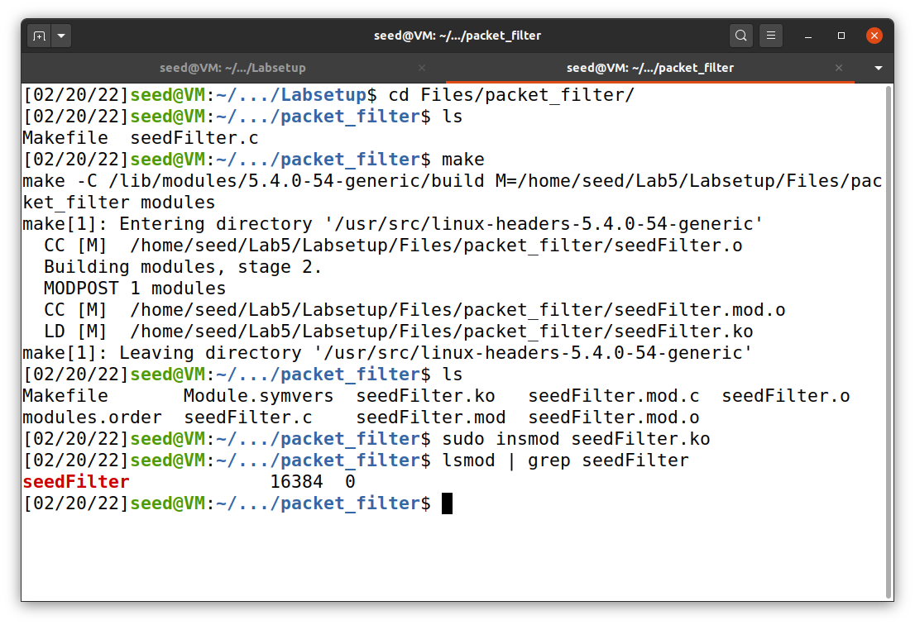

After that, I tried and failed to dig www.pfw.edu with DNS 8.8.4.4 with the command below. That attempt is shown in Figure 8.

dig @8.8.4.4 www.pfw.edu

**Figure 8**

*Filtered dig @8.8.4.4 www.pfw.edu*

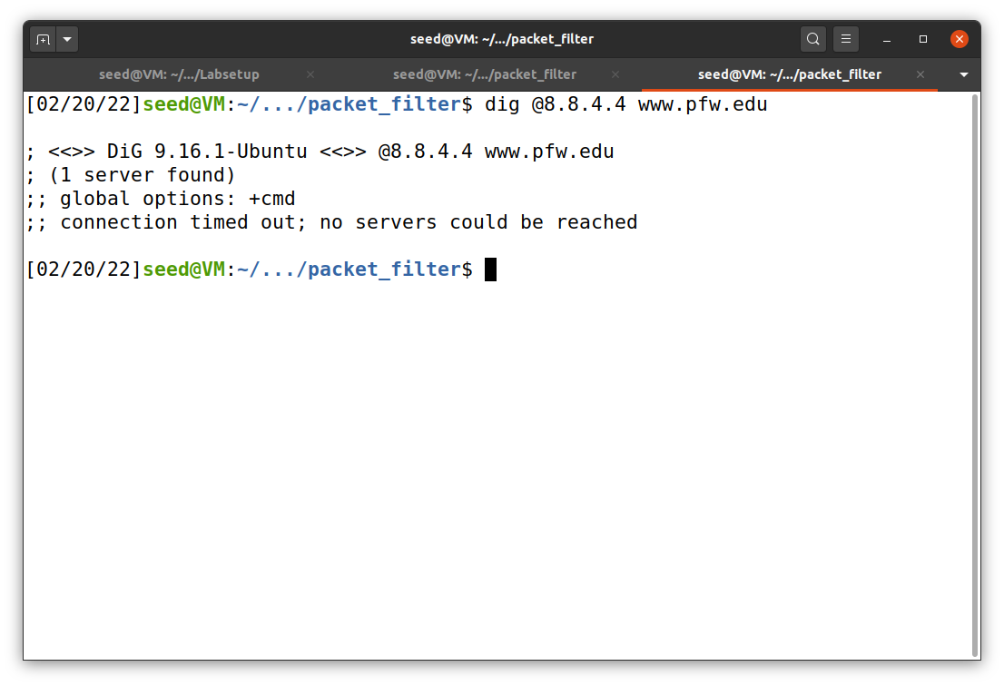

Then, I removed the filter using the command below and dig again (Figure 9). This time dig is successful, as shown in Figure 10.

sudo rmmod seedFilter

**Figure 9**

*Removing seedFilter.ko*

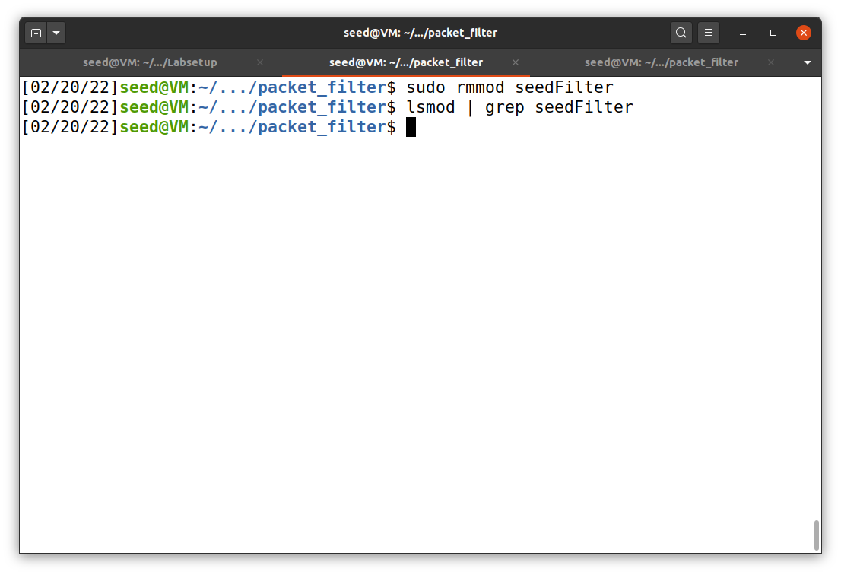

**Figure 10**

*Unfiltered dig @8.8.4.4 www.pfw.edu*

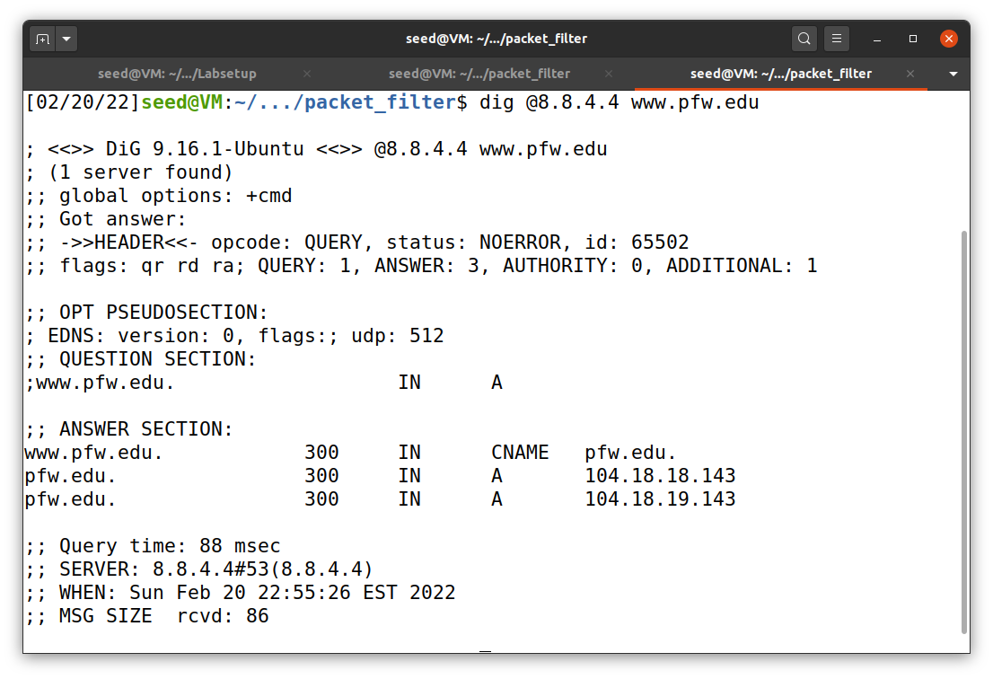

For the second subtask, I changed the hook1.hooknum equal to each of the five hook functions: NF_INET_PRE_ROUTING, NF_INET_LOCAL_IN, NF_INET_FORWARD, NF_INET_LOCAL_OUT, NF_INET_POST_ROUTING. The results are shown below. When I used dig @8.8.4.4 www.pfw.edu, it was all unsuccessful with every hook function and gave the same output as shown in Figure 8.

**Figure 11**

*NF_INET_PRE_ROUTING*

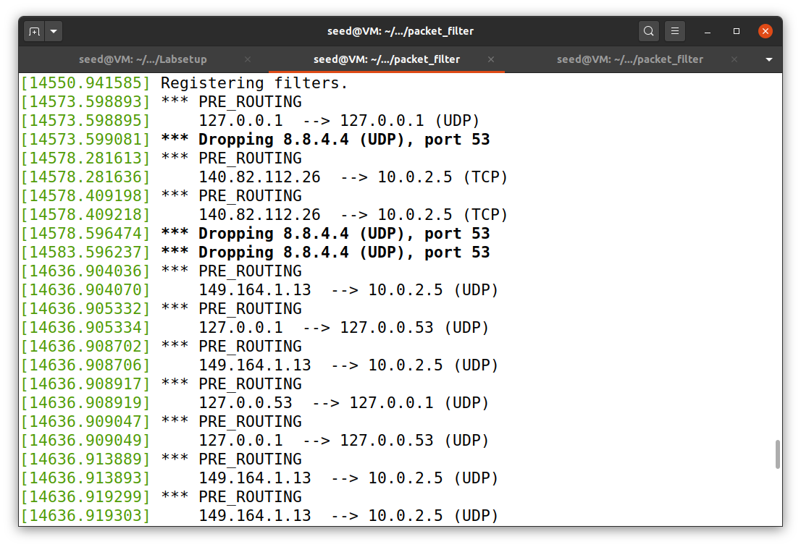

**Figure 12**

*NF_INET_LOCAL_IN*

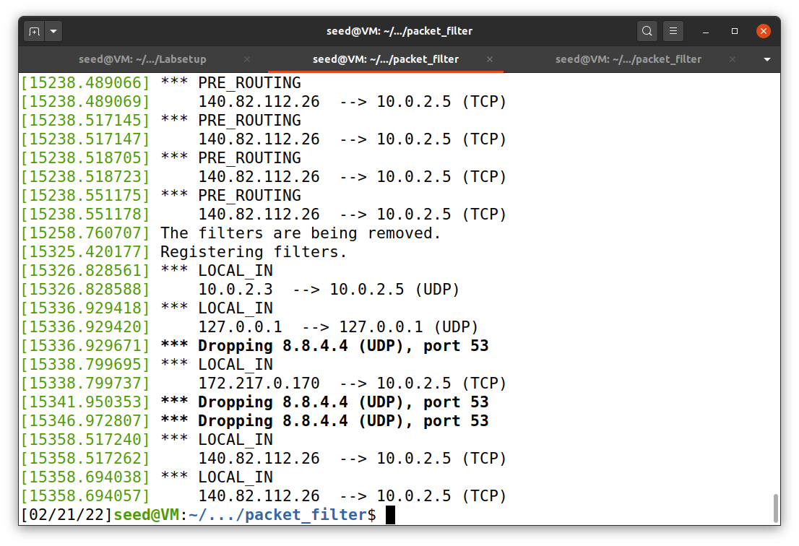

**Figure 13**

*NF_INET_FORWARD*

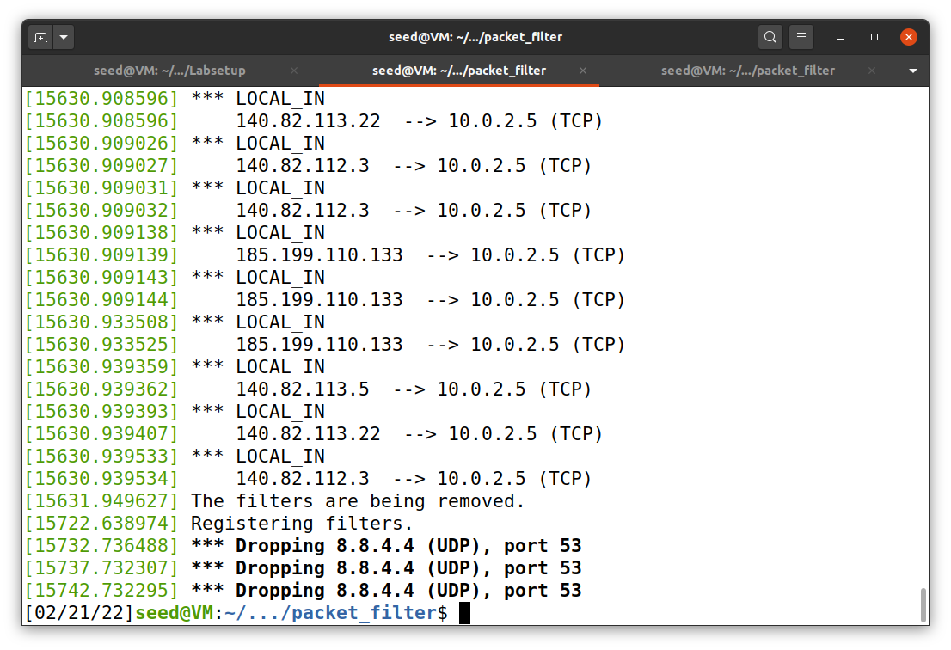

Note: NF_INET_FORWARD, as suggested, is difficult to be observed. As shown in Figure 13, we cannot see any FORWARD pops up.

**Figure 14**

*NF_INET_LOCAL_OUT*

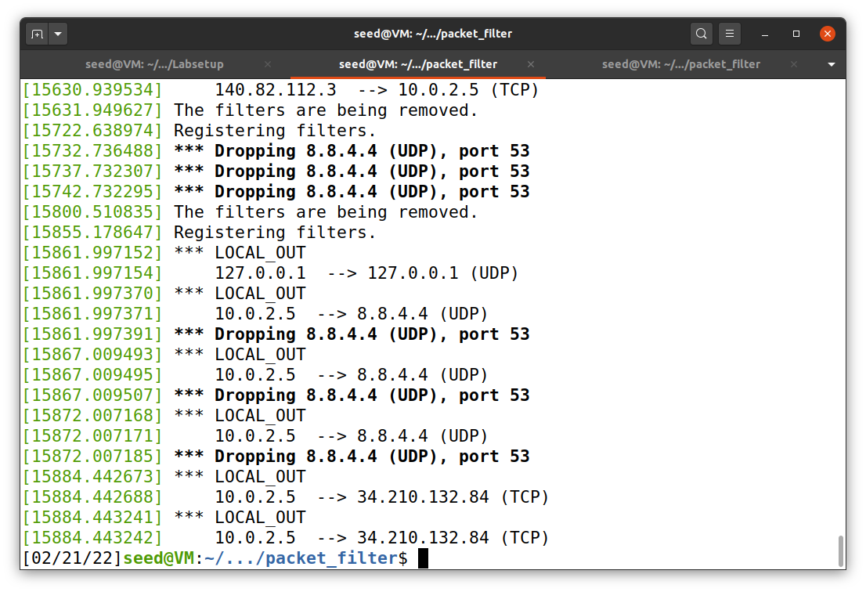

**Figure 15**

*NF_INET_POST_ROUTING*

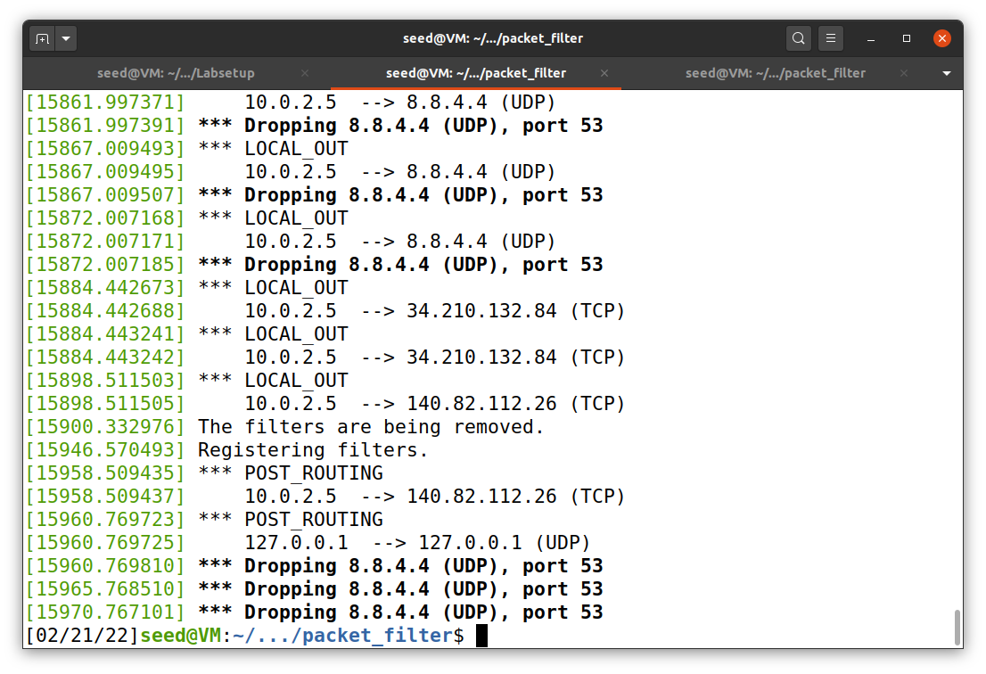

For the last (third) subtask, I reconfigured the seedFilter.c by adding two more hooks. The first hook is used to block ICMP type 8 to prevent other users to ping VM. The second hook block TCP port 23 communication to prevent other users to telnet VM. This code was uploaded to my GitHub repository.

Similar to previous lab, we have to create out network from docker-compose.yml using the command below (Figure 16).

dcbuild

dcup

**Figure 16**

*Lab network creation*

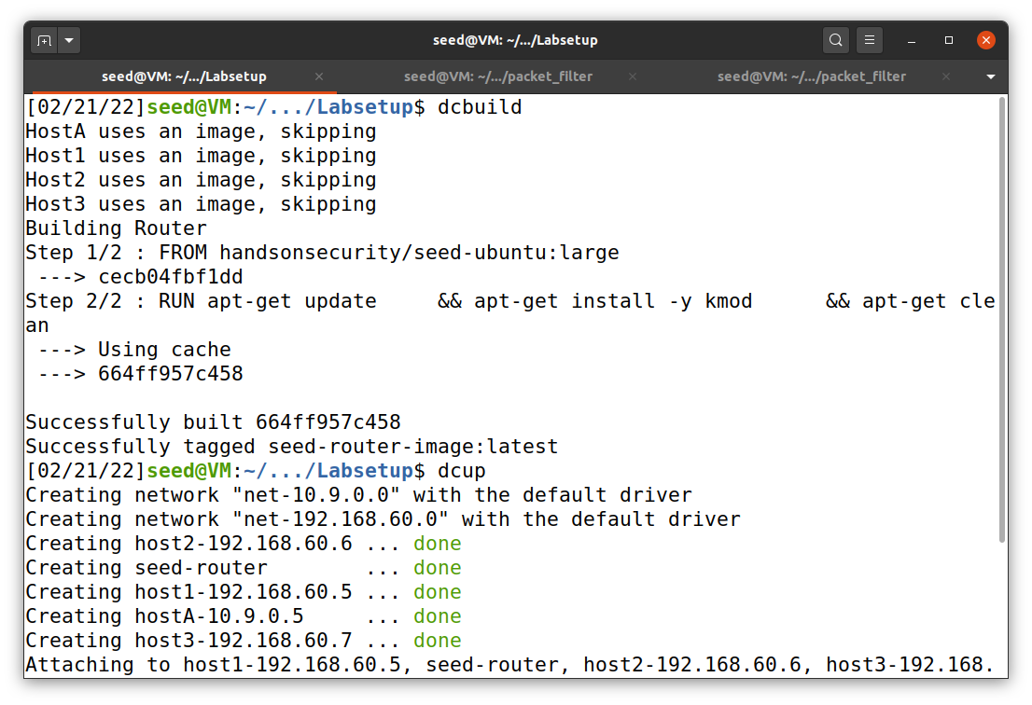

Next, I used the commands make and sudo insmod seedFilter.ko to compile and install the module to kernel. These are shown in Figure 17. To check the installed module, I can use lsmod | grep seedFilter (also shown in Figure 17).

Finally, I docked the hostA to ping and telnet to VM (10.9.0.1), as shown in Figure 18. Both were unsuccessful due to our seedFilter, which can be observed by using dmesg command (Figure 19).

**Figure 17**

*Installation of seedFilter*

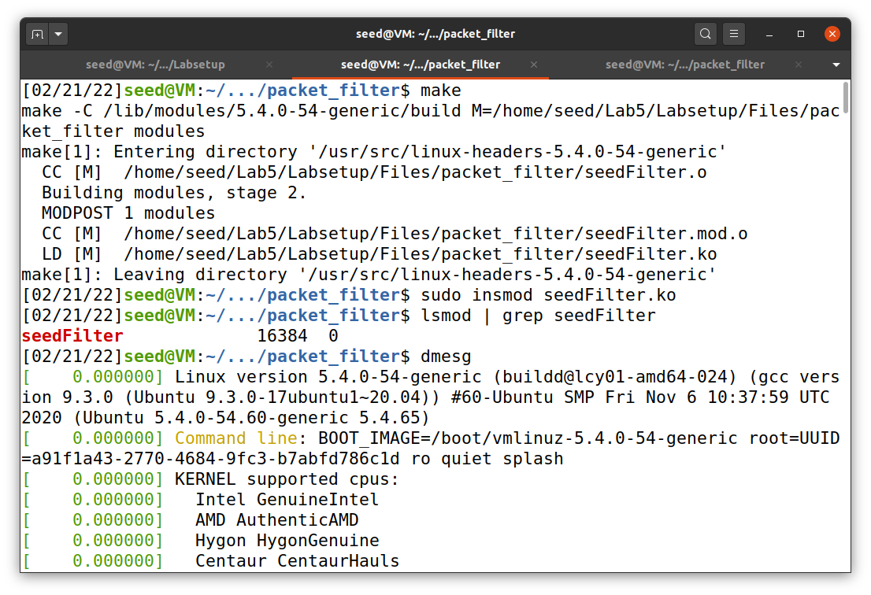

**Figure 18**

*ping and telnet from hostA*

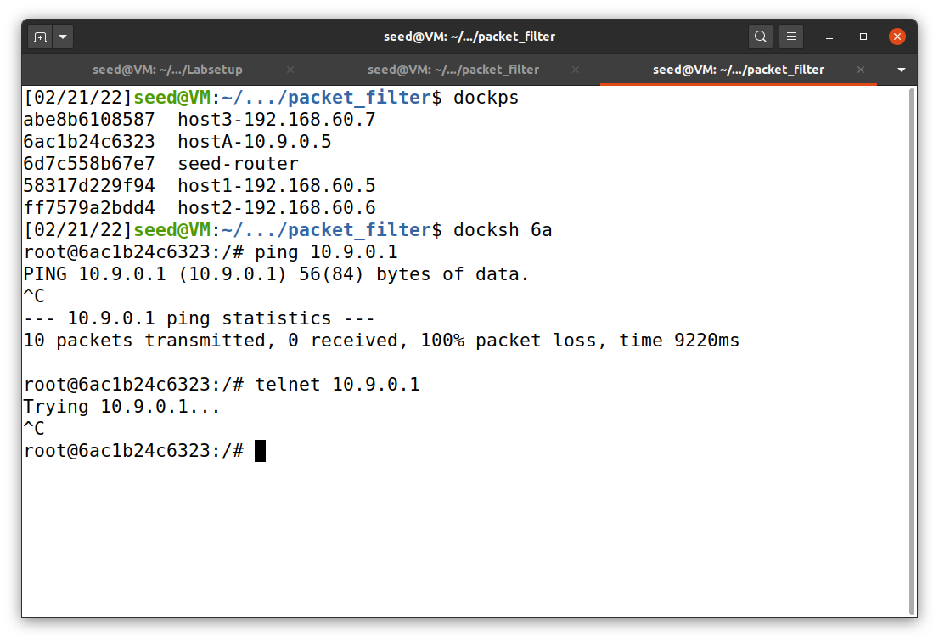

hostA

**Figure 19**

*dmesg*

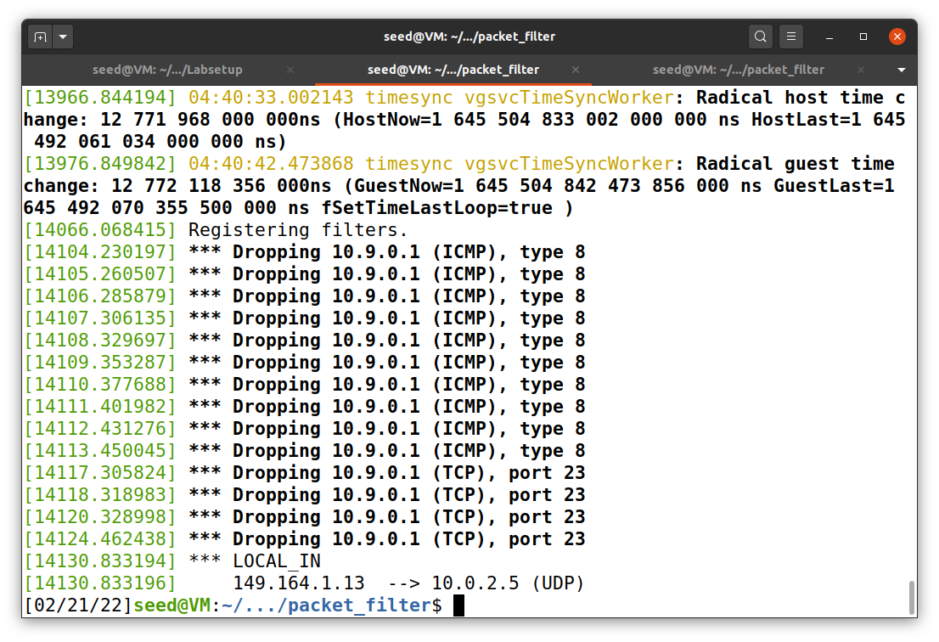

telnet packets removed

(TCP port 23)

ping packets removed

(ICMP type 8)

After we finish this part of the lab, we can use the following command to remove and clear the module (not shown in any Figure).

sudo rmmod seedFilter

make clean

**Task 2: Experimenting with Stateless Firewall Rules**

***Task 2.A: Protecting the Router***

In this task, I used iptables to protect the router. The commands are shown in Figure 20, which are exact same as the ones in seedlab site.

**Figure 20**

*Router protection with iptables*

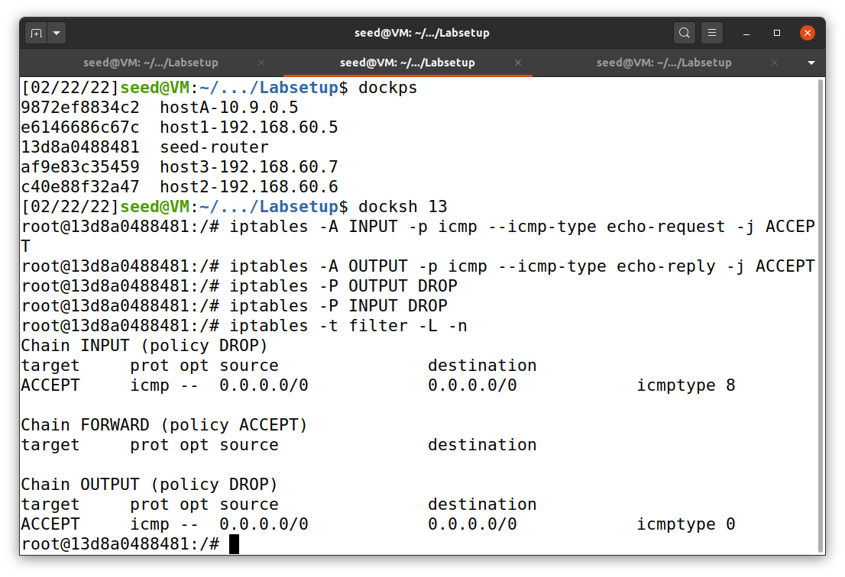

Display iptables rules

iptables rules

Router

The DROP policies (default rules) apply for both INPUT and output but ACCECPT only ICMP echo request (8) and reply (0) type, also known as ping. Then, I used hostA (10.9.0.5) to ping and telnet the router. The result is shown in Figure 21.

**Figure 21**

*hostA telnet and ping router*

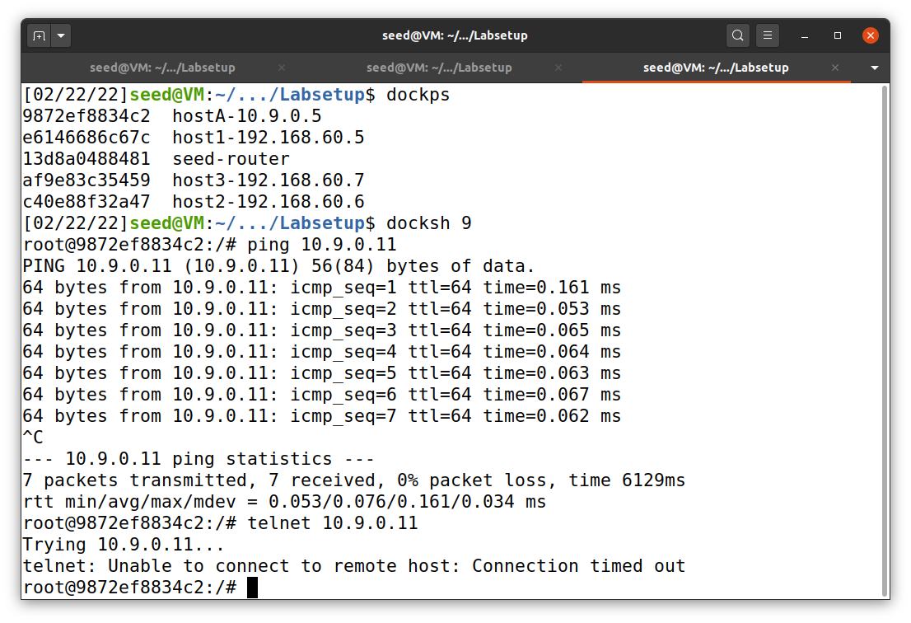

telnet the router and failed

hostA

ping the router and success

Now, the task 2.A is done. However, before we move to the next task, we have to reset the rules of the router. To do this, we can put the command below, but for simplicity I used docker restart 6d to reset the router (Figure 22).

iptables -F

iptables -P OUTPUT ACCEPT

iptables -P INPUT ACCEPT

**Figure 22**

*Restart the router*

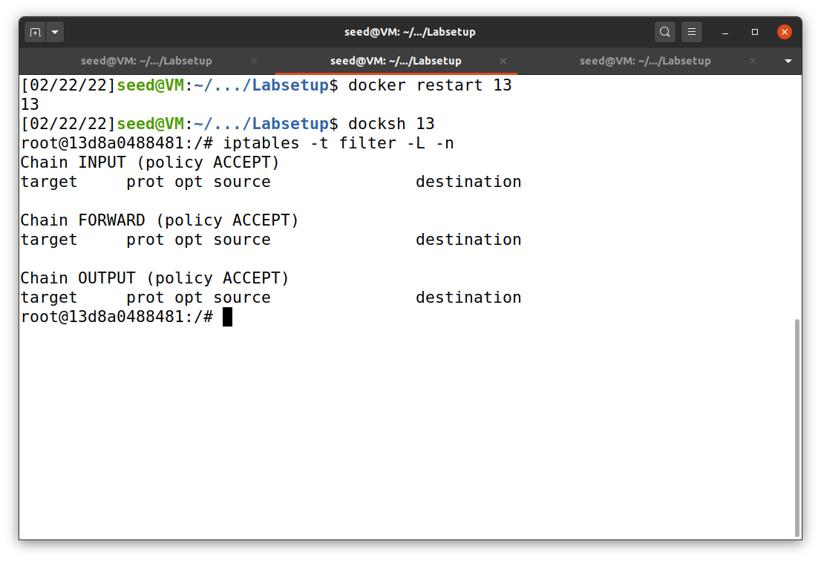

All rules are gone!

restart the router

***Task 2.B: Protecting the Internal Network***

After resetting the router, we can put all new iptables rules as shown below and in Figure 23. Moreover, all outputs are shown in Figure 24 and 25.

iptables -A FORWARD -i eth0 -p icmp --icmp-type echo-request -j DROP

iptables -A FORWARD -i eth1 -p icmp --icmp-type echo-request -j ACCEPT

iptables -A FORWARD -p icmp --icmp-type echo-reply -j ACCEPT

iptables -P FORWARD DROP <<< default policy

**Figure 23**

*Router’s iptables for task 2.B*

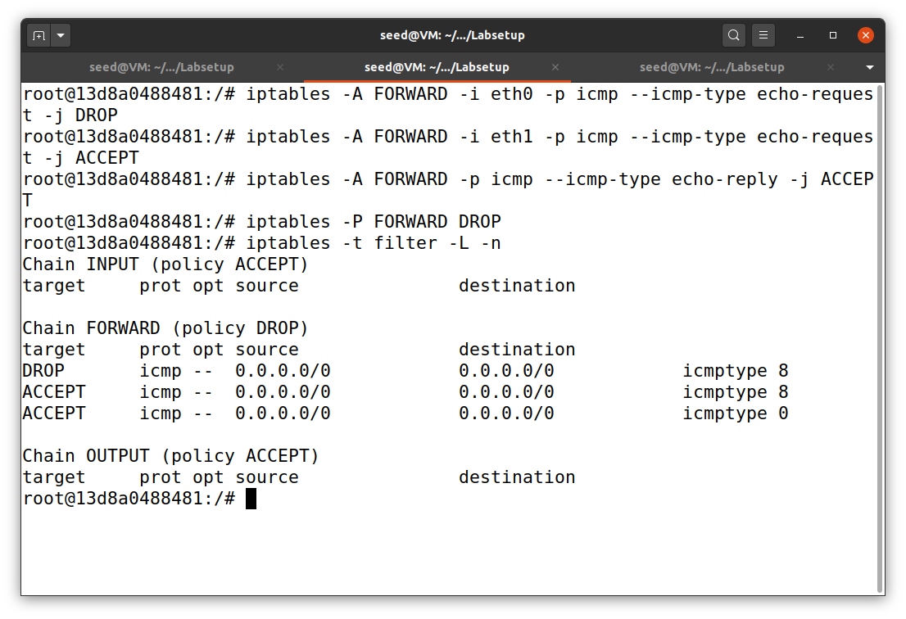

Router

**Figure 24**

*Host1’s output for task 2.B*

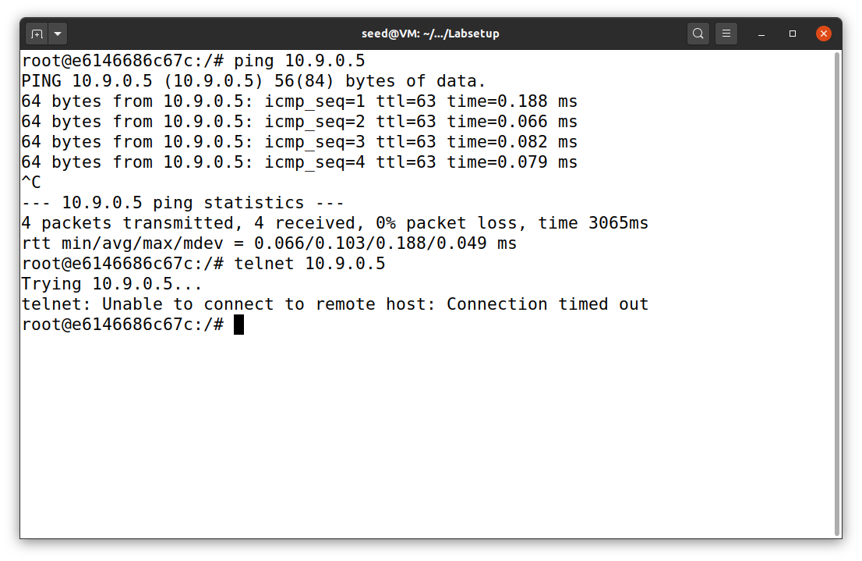

host 1 cannot telnet host A

host 1 can ping host A

Host 1

**Figure 25**

*HostA’s output for task 2.B*

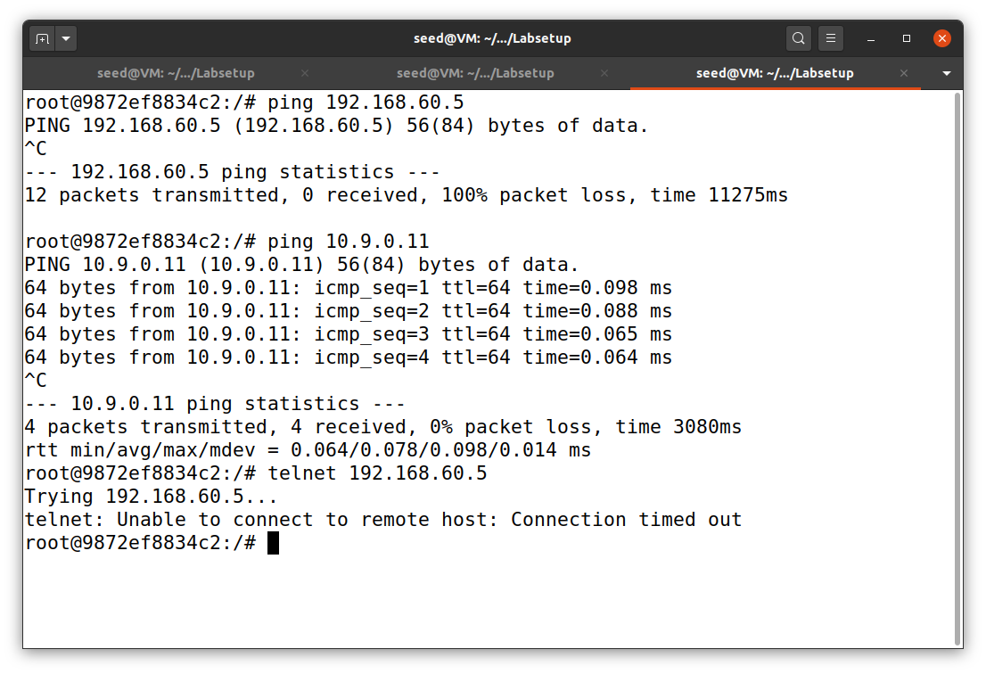

host A cannot telnet host 1

host A can ping the router

host A cannot ping host 1

Host A

Note: The first router rule (iptables -A FORWARD -i eth0 -p icmp --icmp-type echo-request -j DROP) can be omitted because it has already been applied with the default policy (iptables -P FORWARD DROP).

***Task 2.C: Protecting Internal Servers***

I used the command below to add rules to iptables of the router, as shown in Figure 26. They allow external users (in this case host A) to telnet only host 1. Actually, I will copy and paste all conditions that it have to meet from seedLab site down below.

The results are shown in Figure 27 to 30.

* All the internal hosts run a telnet server (listening to port 23). Outside hosts can only access the telnet server on 192.168.60.5, not the other internal hosts.
* Outside hosts cannot access other internal servers.
* Internal hosts can access all the internal servers.
* Internal hosts cannot access external servers.
* In this task, the connection tracking mechanism is not allowed.

iptables -A FORWARD -i eth0 -p tcp -d 192.168.60.5 --dport 23 -j ACCEPT

iptables -A FORWARD -i eth1 -p tcp -s 192.168.60.5 --sport 23 -j ACCEPT iptables -P FORWARD DROP <<< default policy

**Figure 26**

*Router’s iptables for task 2.C*

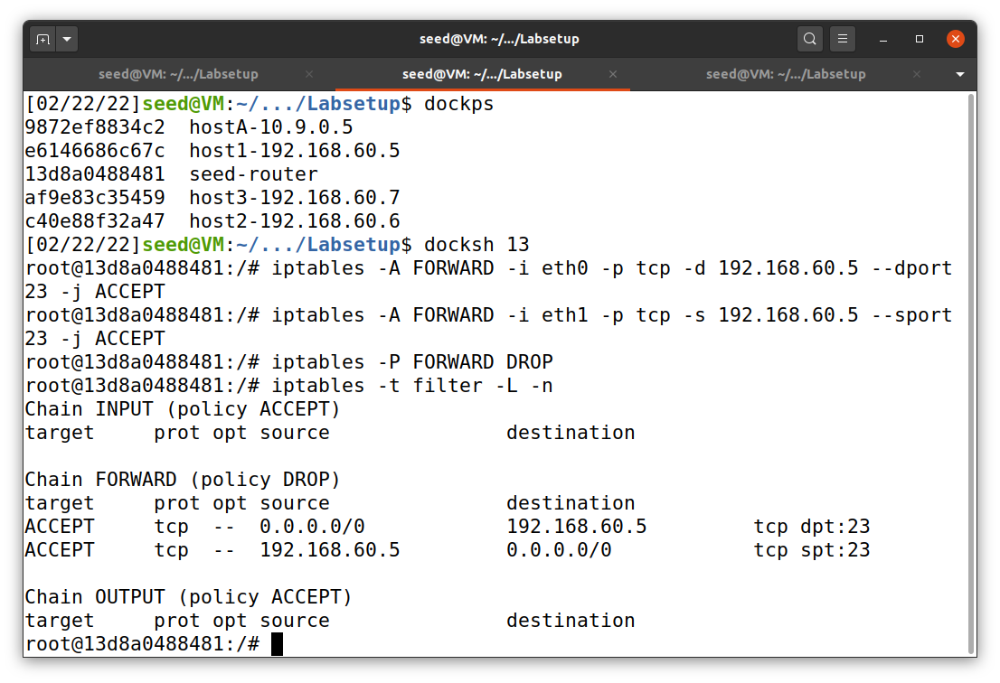

Router

**Figure 27**

*HostA’s output for task 2.C*

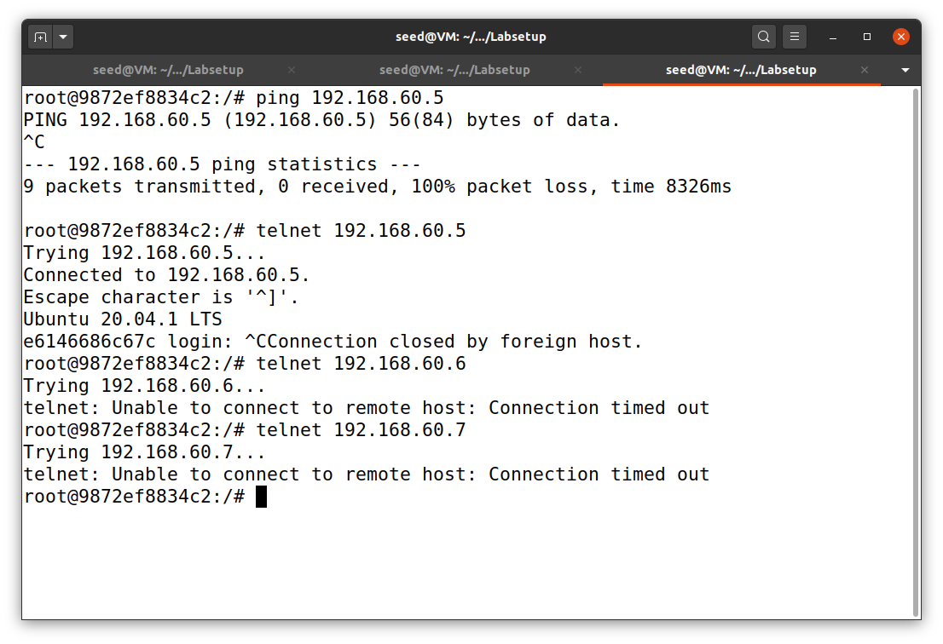

host A cannot telnet host 3

host A cannot telnet host 2

host A can telnet host 1

host A cannot ping host 1

(internal server)

hostA

**Figure 28**

*Host1’s output for task 2.C*

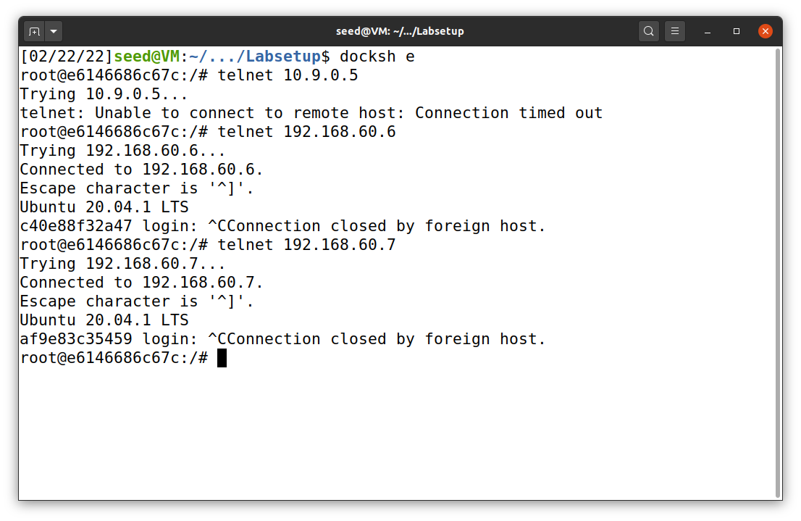

host 1 can telnet host 3

host 1 can telnet host 2

host 1 cannot telnet host A

host1

**Figure 29**

*Host2’s output for task 2.C*

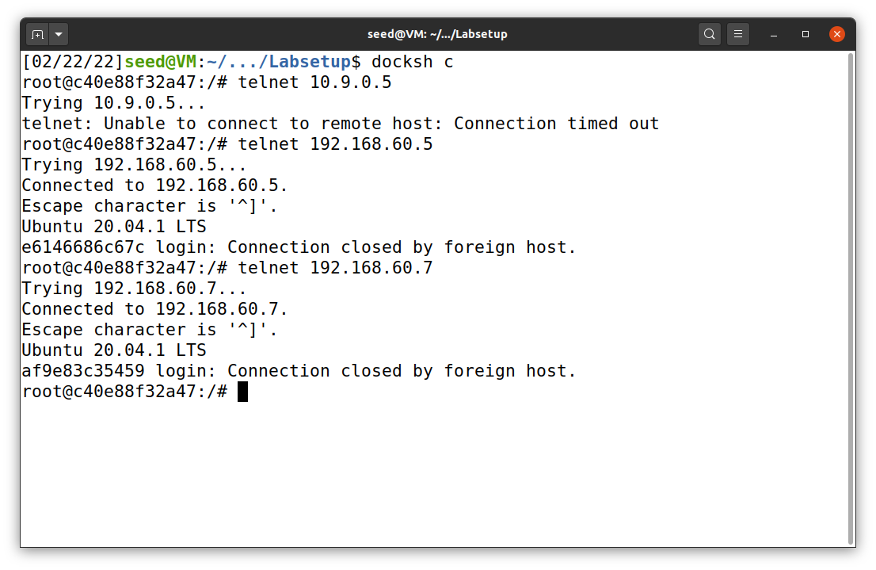

host 2 can telnet host 3

host 2 can telnet host 1

host 2 cannot telnet host A

host2

**Figure 30**

*Host3’s output for task 2.C*

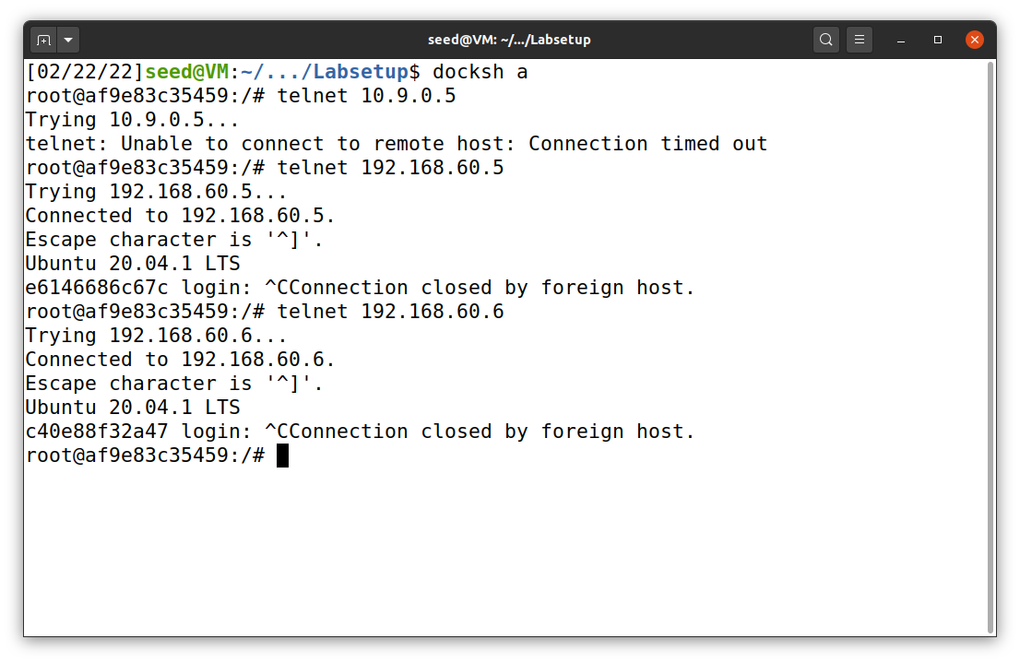

host 3 can telnet host 2

host 3 can telnet host 1

host 3 cannot telnet host A

host3

**Task 3: Connection Tracking and Stateful Firewall**

***Task 3.A: Experiment with the Connection Tracking***

This task is an easy one. The command below has to be put into the router after any successful connections.

conntrack -L

I started with ICMP connection by using ping command from host A to host 1, as shown in Figure 31. Once the connection has been made, the command above will be able to show us. In this case, it is the ICMP connection from source 10.9.0.5 to destination 192.168.60.5 with type 8 (echo request) and then get type 0 (echo reply). It also shows the time left in the connection state. It will be counting down after the connection is done. According to Figure 31, there are 27 seconds remaining. If we keep pinging, the time will be reset.

**Figure 31**

*Connection tracking on ICMP*

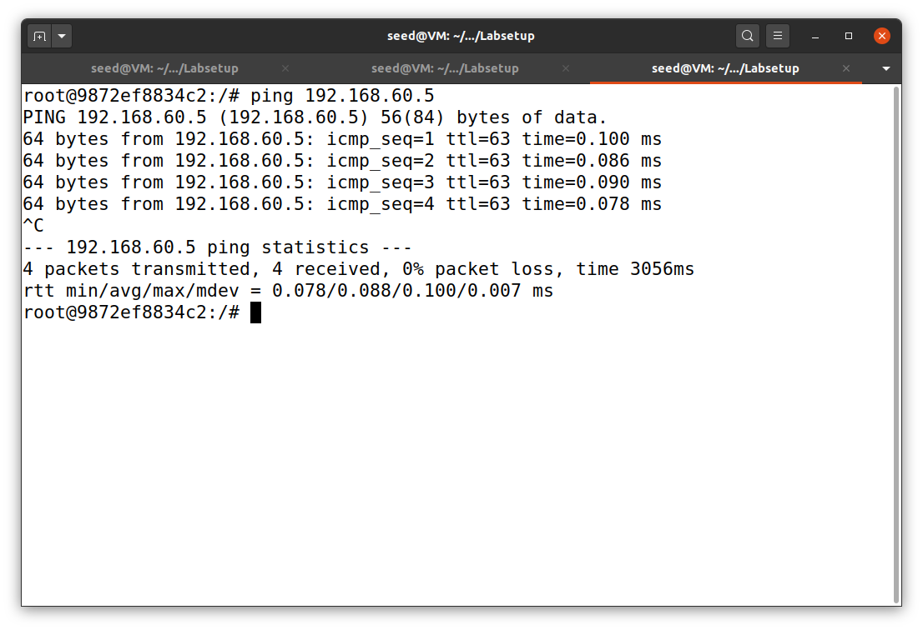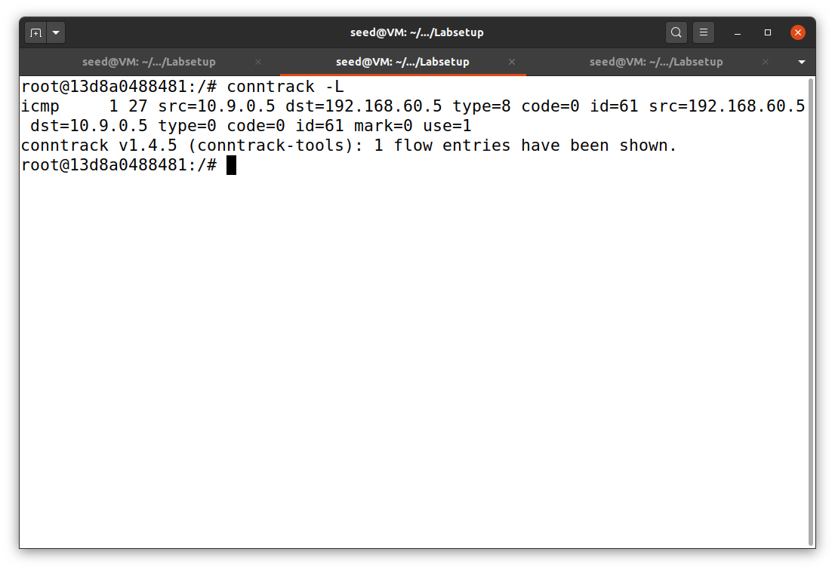

router

hostA

Next, I tested with UDP connection by using the command nc -lu 9090 on host 1 and nc -u 192.168.60.5 9090 on host A. The results are shown in Figure 32. The conntrack -L command shows that there are 27 seconds remaining at first. When I reapply the command, it is already out of a connection state.

**Figure 32**

*Connection tracking on UDP*

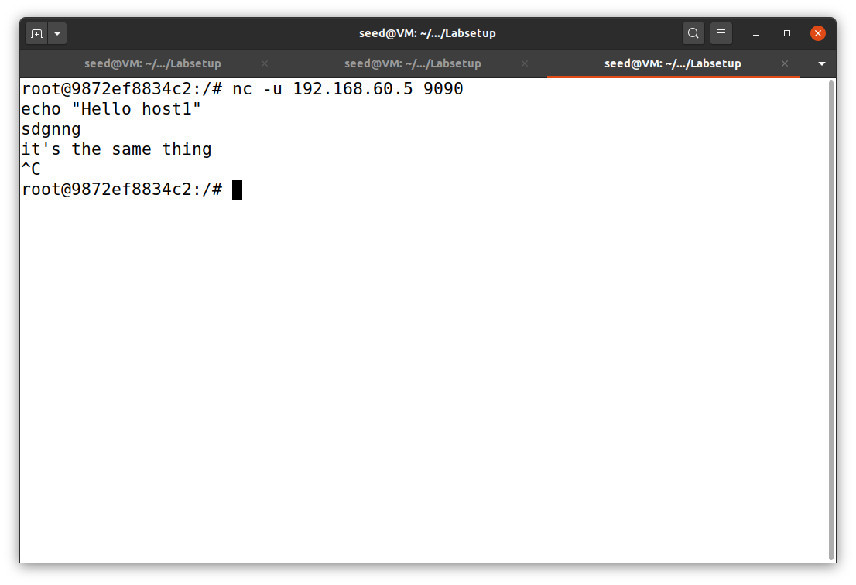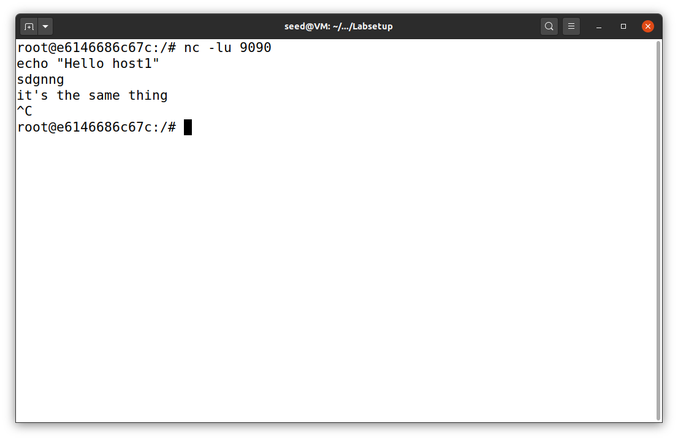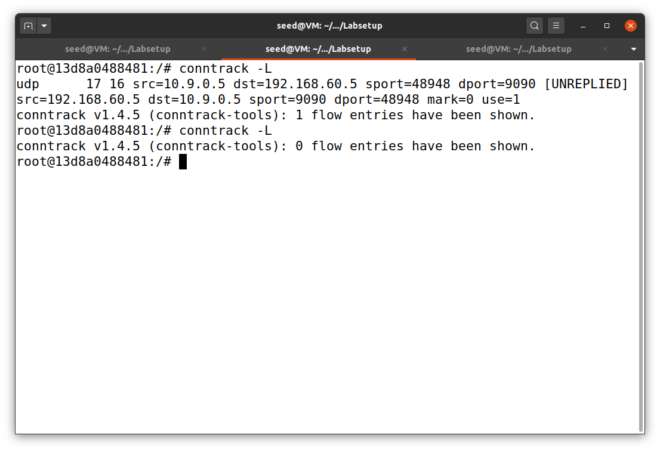

router

host1

hostA

After that, I tested with TCP connection by using the command nc -l 9090 on host 1 and nc 192.168.60.5 9090 on host A. The results are shown in Figure 33. The conntrack -L command shows that there are 117 seconds remaining at first. When I reapply the command, it there are 87 seconds remaining and then out of a connection state. The TCP connection seems to be kept in the connection state longest out of the three protocols.

**Figure 33**

*Connection tracking on TCP*

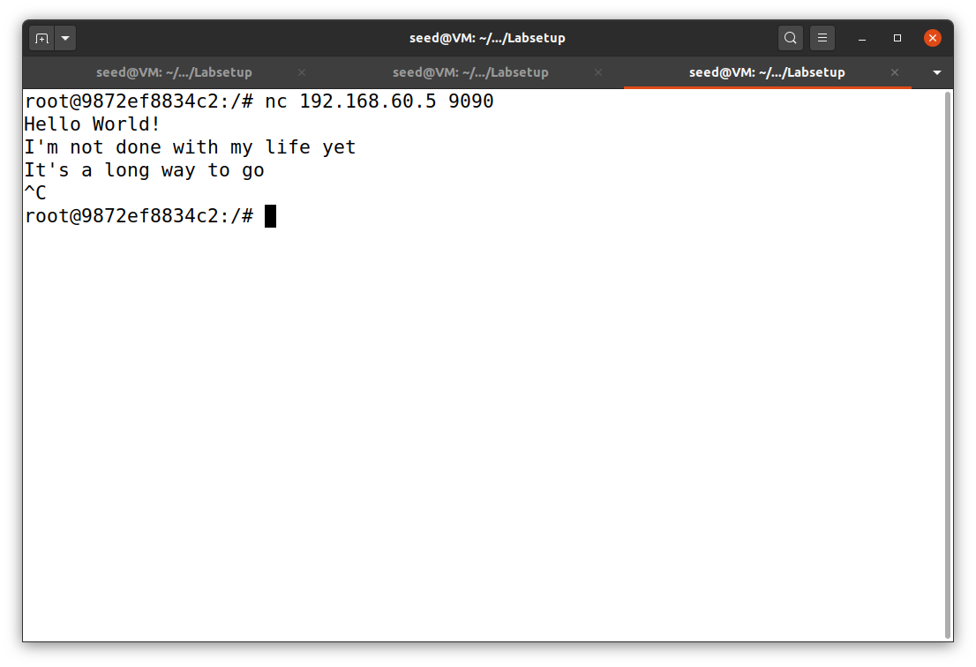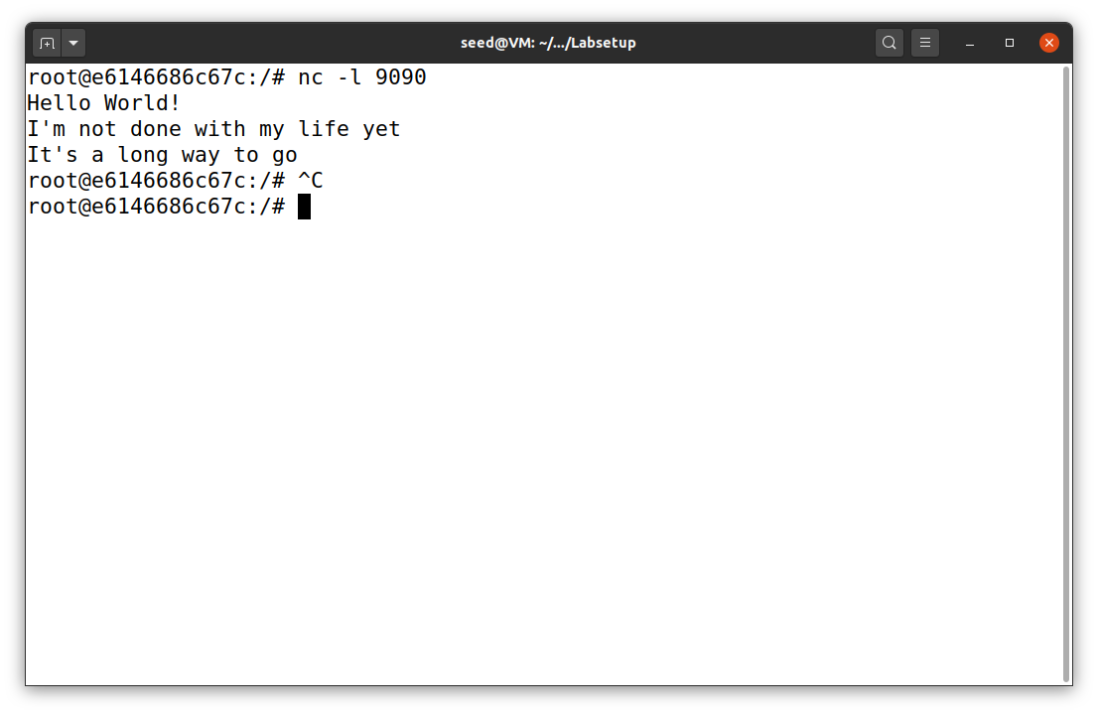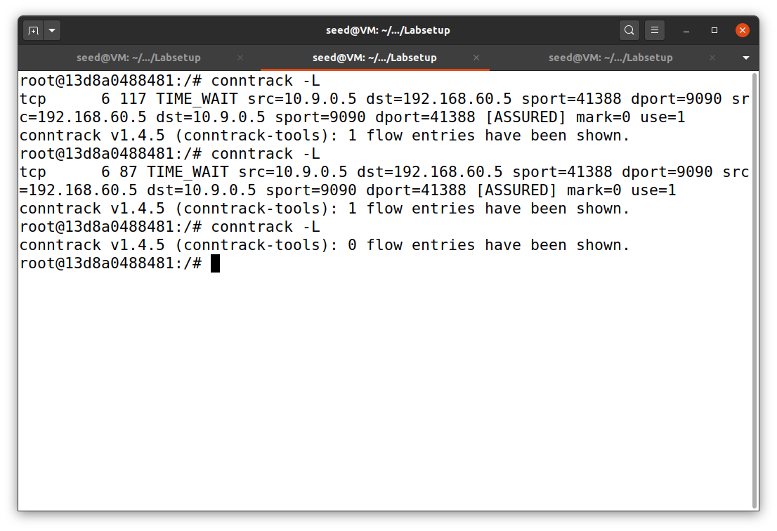

host1

router

hostA

***Task 3.B: Setting Up a Stateful Firewall***

In this task, I just want to focus on iptables for TCP packets, which include telnet. The rules are similar to task 2.C but the internal hosts can access external servers. The objectives are listed below.

* All the internal hosts run a telnet server (listening to port 23). Outside hosts can only access the telnet server on 192.168.60.5, not the other internal hosts.
* Outside hosts cannot access other internal servers.
* Internal hosts can access all the internal servers.
* Internal hosts can access external servers.

**Figure 34**

*Router’s iptables for task 3.B*

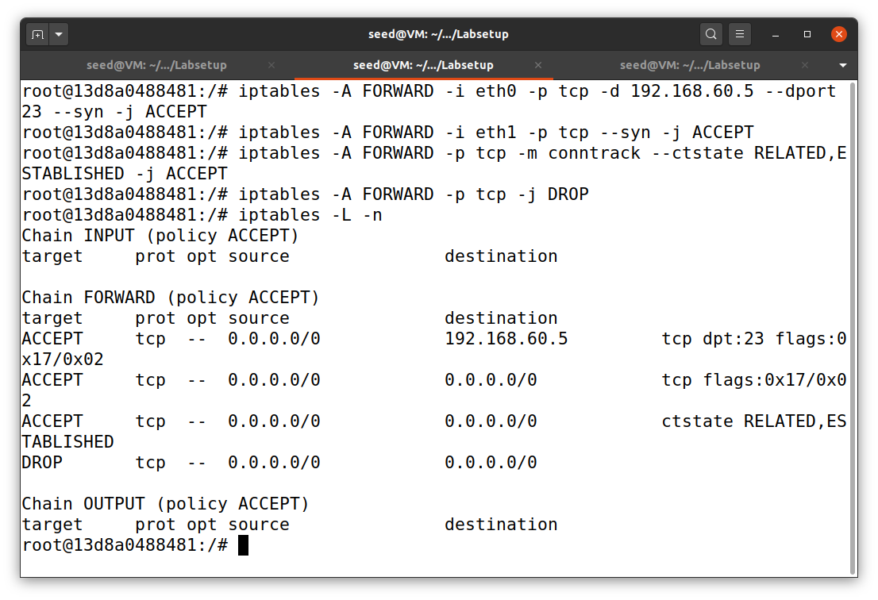

router

iptables -A FORWARD -i eth0 -p tcp -d 192.168.60.5 --dport 23 --syn -j ACCEPT

iptables -A FORWARD -i eth1 -p tcp --syn -j ACCEPT

iptables -A FORWARD -i eth0 -p tcp -m conntrack –ctstate RELATED,ESTABLISHED -j ACCEPT

iptables -A FORWARD -p tcp -j DROP

The second rule allow g internal hosts to visit any external server. The results of this task are shown in Figure 35 to 39.

**Figure 35**

*HostA’s output for task 3.B*

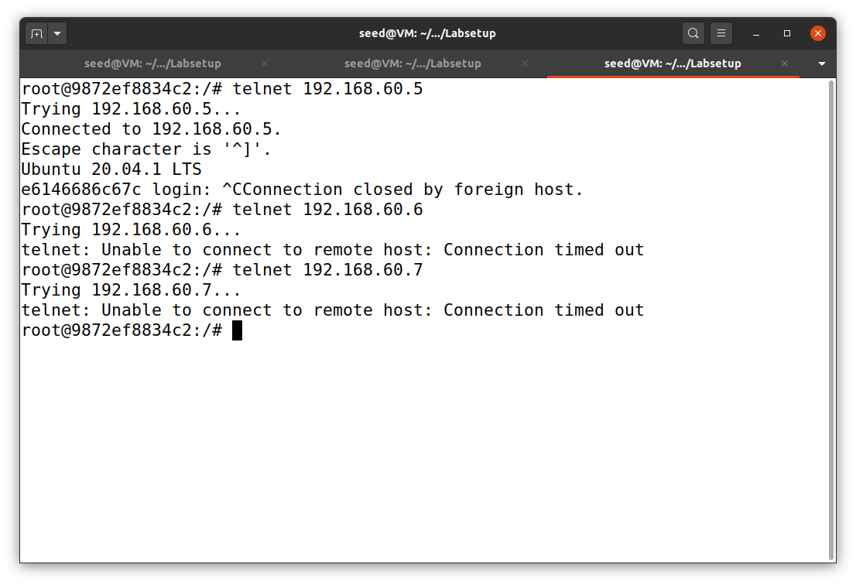

host A cannot telnet host 3

host A cannot telnet host 2

hostA

host A can telnet host 1

**Figure 36**

*Host1’s output for task 3.B*

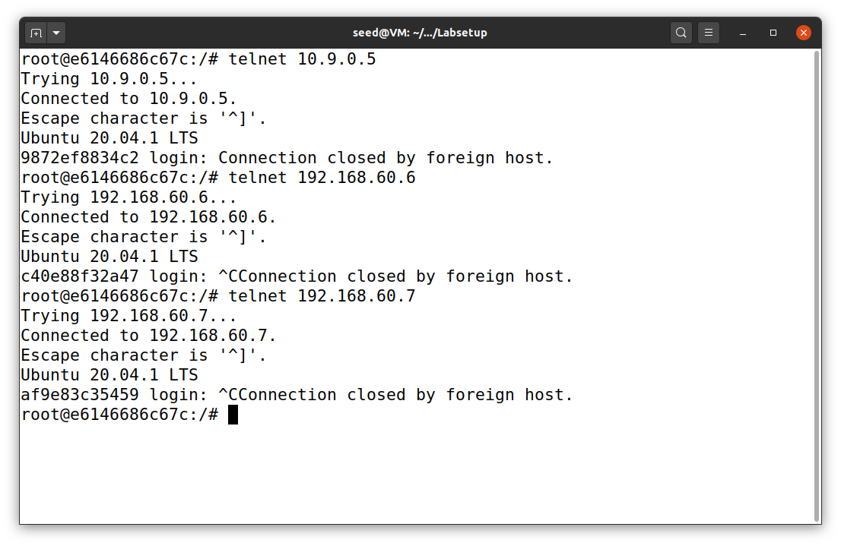

host 1 can telnet host 3

host 1 can telnet host 2

host1

host 1 can telnet host A

**Figure 37**

*Host2’s output for task 3.B*

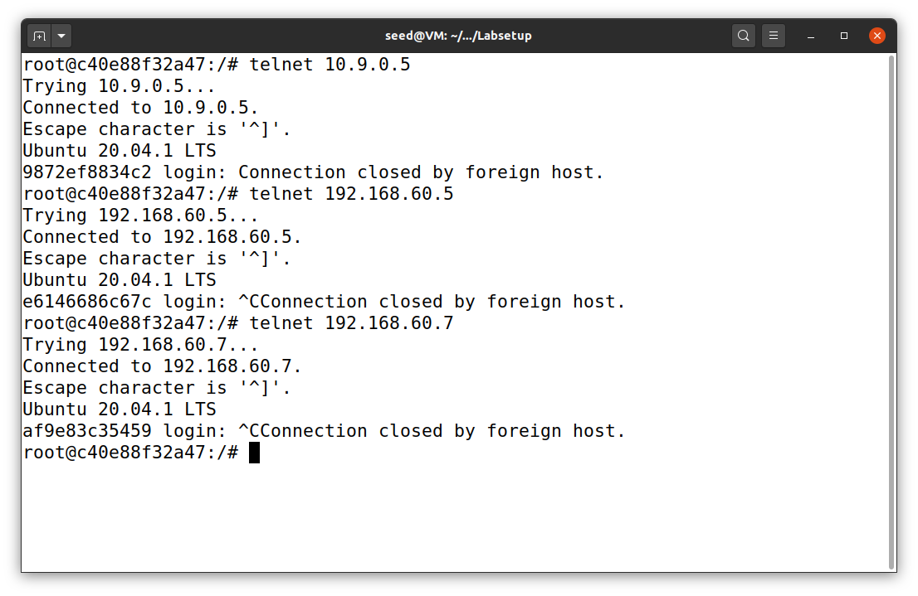

host 2 can telnet host 1

host 2 can telnet host 3

host2

host 2 can telnet host A

**Figure 38**

*Host3’s output for task 3.B*

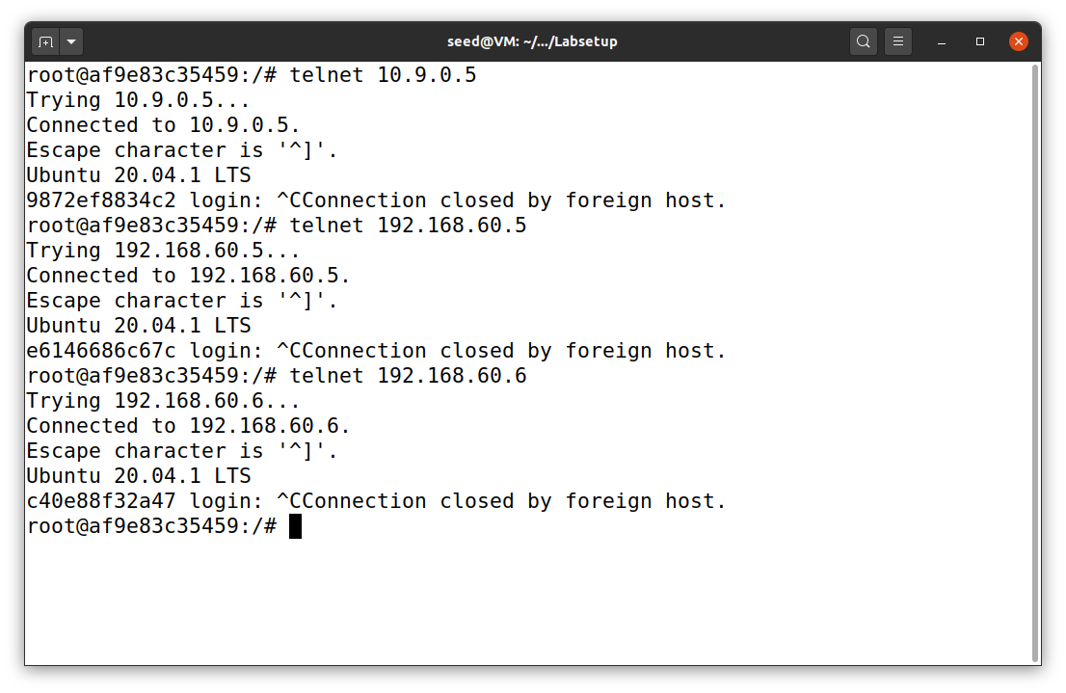

host 3 can telnet host 1

host 3 can telnet host 2

host3

host 3 can telnet host A

**Figure 39**

*conntrack module’s output*

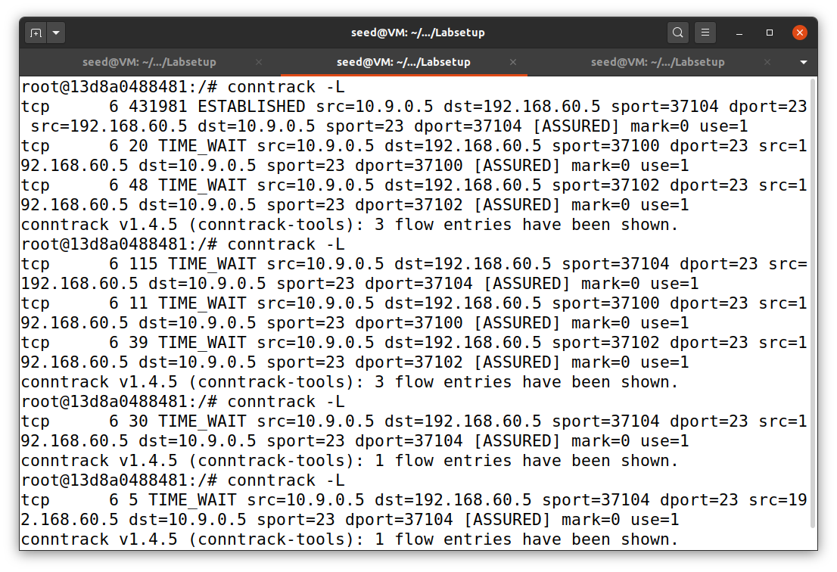

router

Figure 39 shows the conntrack module’s output when I tried to make host A (10.9.0.5) telnet host 1 (192.168.60.5). The conntrack -L clearly show us that we have the connection ESTABLISHED. After I exit the telnet server on host A, the connection status changed to TIME_WAIT and start countdown timer. If the timer finish, it will no longer be in the connection state.

The other approach may be to implement with tcpdump and Wireshark. Even though its interface is much clearer, that might take some time to view the connection status. By including conntrack module into the rule, it is more convenient and fast.

**Task 4: Limiting Network Traffic**

Before tackling this task, I have reset the router as shown in the previous task. Then, I added two new rules to the iptables of the router, as shown in Figure 40.

iptables -A FORWARD -s 10.9.0.5 -m limit --limit 10/minute --limit-burst 5 -j ACCEPT

iptables -A FORWARD -s 10.9.0.5 -j DROP

**Figure 40**

*Router’s iptables for task 4*

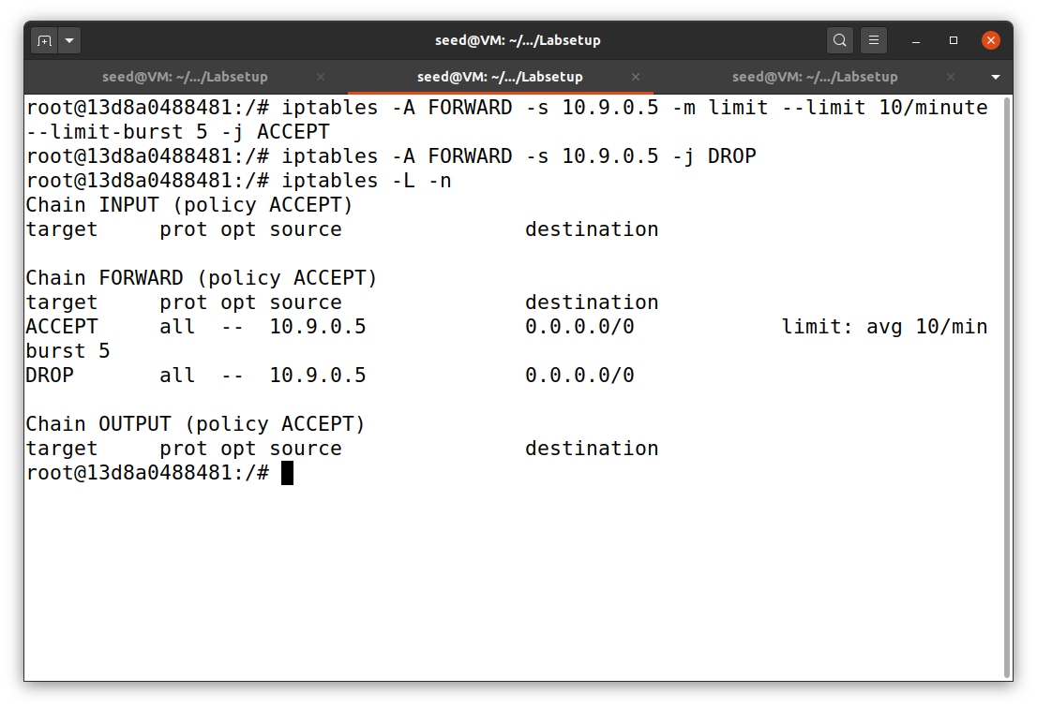

router

From the rules above, they all the packets coming from hostA (10.9.0.5) to 10 packets per minute with initial burst of 5 packets. The result is shown in Figure 41.

**Figure 41**

*HostA’s output for task 4*

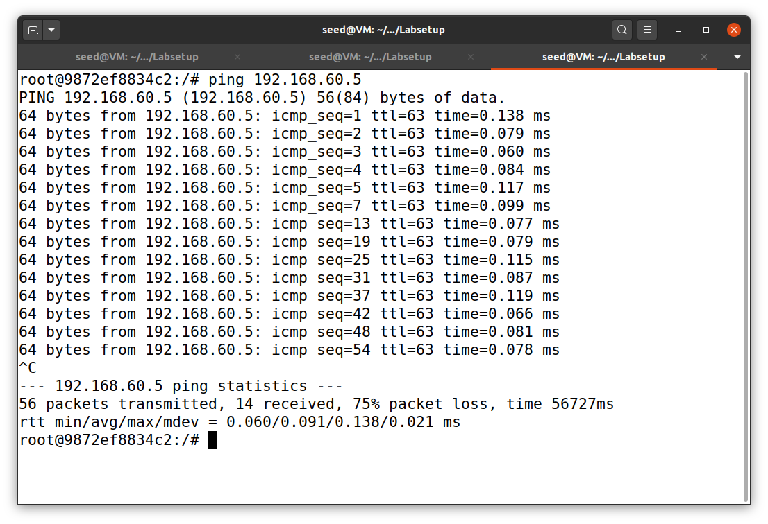

10 packets/min

5 initial bursts

hostA

Next, I restarted the router and try it again without the second rule. The result clearly shows that network limitation mechanism does not work at all, as shown in Figure 42. This is because we do not have any rule to drop packets. In other word, we just ACCEPT all packets!

In order for the system to work, we must have both rules. The first one will select the corresponding packets and ACCEPT them. The second will DROP any packet that has not been accepted by the first rule.

**Figure 42**

*The result of task 4 without second rule*

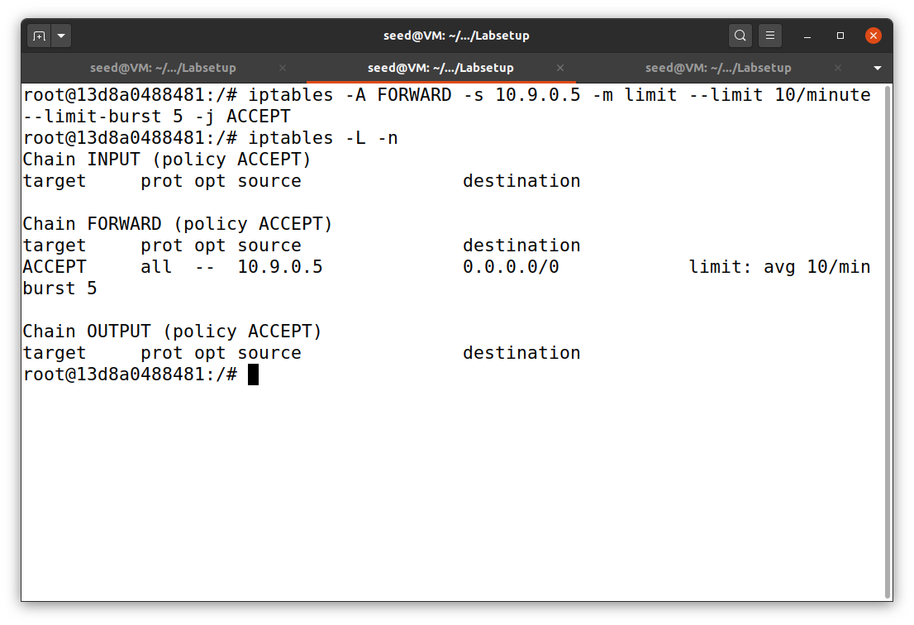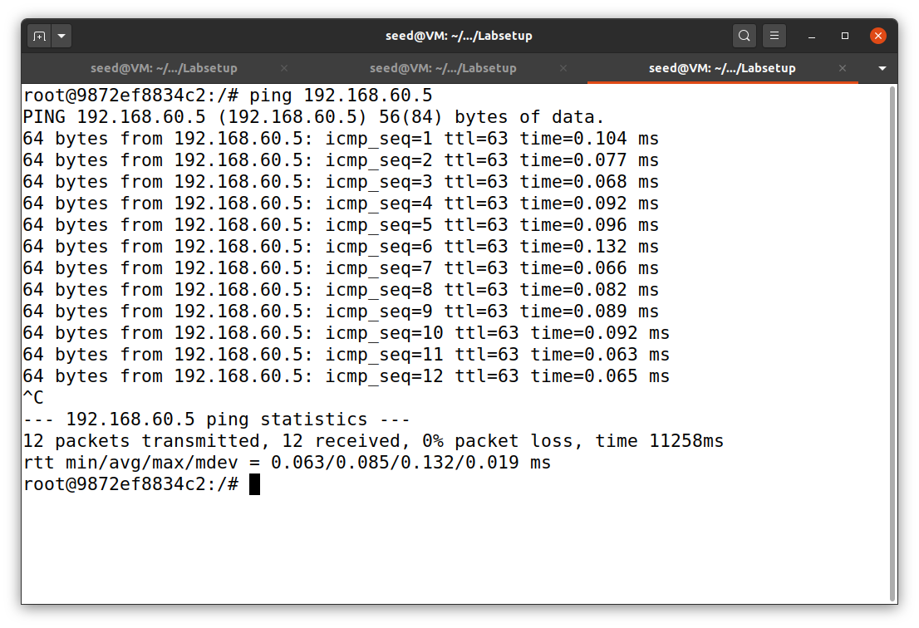

All packets were accepted

hostA

router

**Task 5: Load** Balancing

I reset the router and apply new rules to the router, as shown in Figure 43. In the first part, I utilized the statistic module with round-robin (nth) mode to distribute the loads between host 1, 2, and 3 (192.168.60.5, 192.168.60.6, and 192.168.60.7). The commands are long and shown below.

* iptables -t nat -A PREROUTING -p udp --dport 8080 -m statistic --mode nth --every 3 --packet 0 -j DNAT --to-destination 192.168.60.5:8080
* iptables -t nat -A PREROUTING -p udp --dport 8080 -m statistic --mode nth --every 2 --packet 0 -j DNAT --to-destination 192.168.60.6:8080
* iptables -t nat -A PREROUTING -p udp --dport 8080 -j DNAT --to-destination 192.168.60.7:8080

**Figure 43**

*Router’s iptables rules*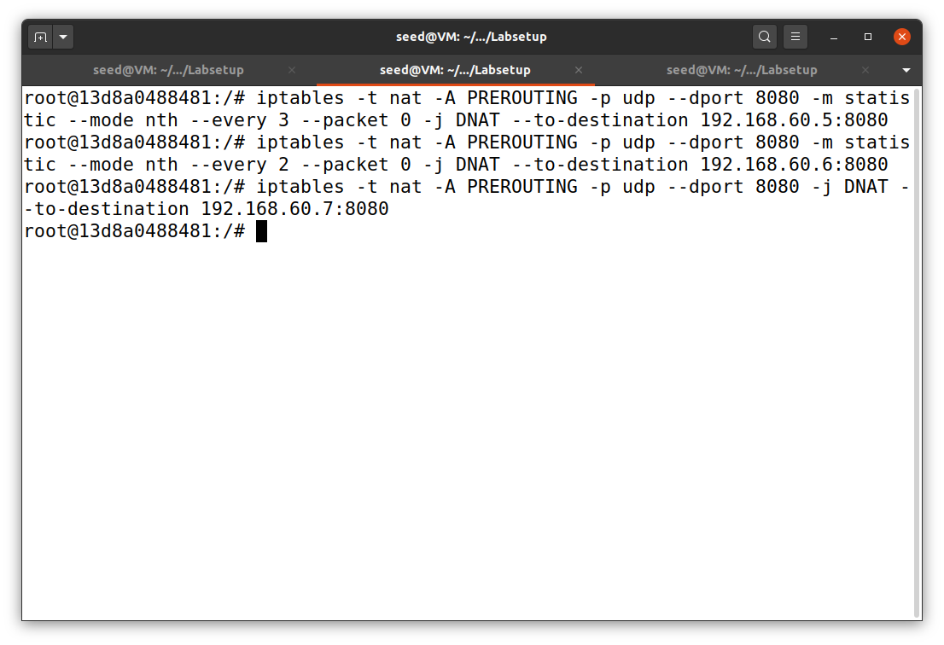

Once the commands were set, I established the UDP server on each host by using netcat on port 8080 (nc -luk 8080). Then, on host A (10.9.0.5), I used the command echo hello | nc -u 10.9.0.11 8080 to send the message to the destination servers. The messages were distributed equally to the server in an order from host 1 to 3. The results are shown in Figure 44.

**Figure 43**

*The result of task 4 with RR scheme*

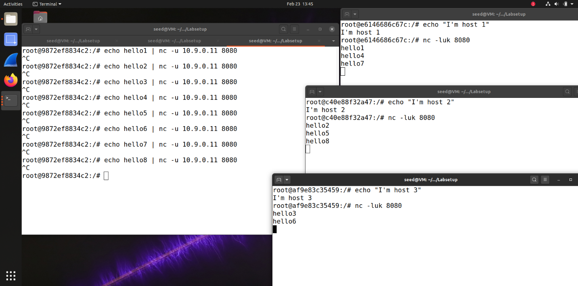

host3

host2

host1

hostA

Finally, I changed the command to apply statisic module with random mode with the probability of 0.33 for each host. The command and the results are shown below. Host 1, 2, and 3 get the messages equally (on average) but the sequence of the message are random.

* iptables -t nat -A PREROUTING -p udp --dport 8080 -m statistic --mode random --probability 0.33 -j DNAT --to-destination 192.168.60.5:8080
* iptables -t nat -A PREROUTING -p udp --dport 8080 -m statistic --mode random --probability 0.33 -j DNAT --to-destination 192.168.60.6:8080
* iptables -t nat -A PREROUTING -p udp --dport 8080 -j DNAT --to-destination 192.168.60.7:8080

**Figure 44**

*The result of task 5 with random scheme*

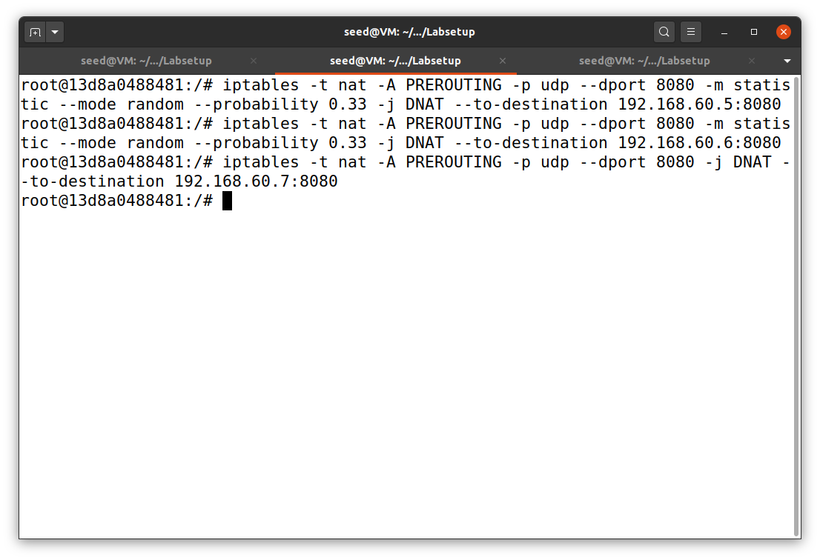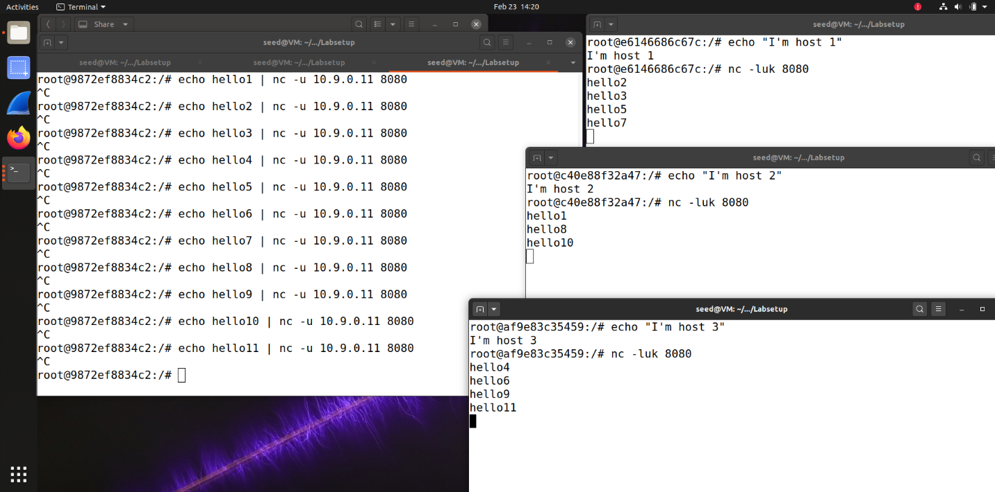

hostA

host3

host2

host1

router

**References**

Du, W. (2019). Computer & internet security: A hands-on approach (2nd ed.). Independently published.

Du, W. (n.d.). Firewall Exploration Lab. SeedLabs 2.0. https://seedsecuritylabs.org/Labs_20.04/‌Networking/Firewall/